Davian Perez-Silva

CSET 115 Technical Requirement

11/22/2017

Extra Credit

Our hangout meeting went very well as usual we did our daily stand up meeting but this time it wasn’t face to face. We talked about what each of us were going to do by the end of the day I was going to finish the aside while Edgar and Jessie make progress on the CSS for the main page.

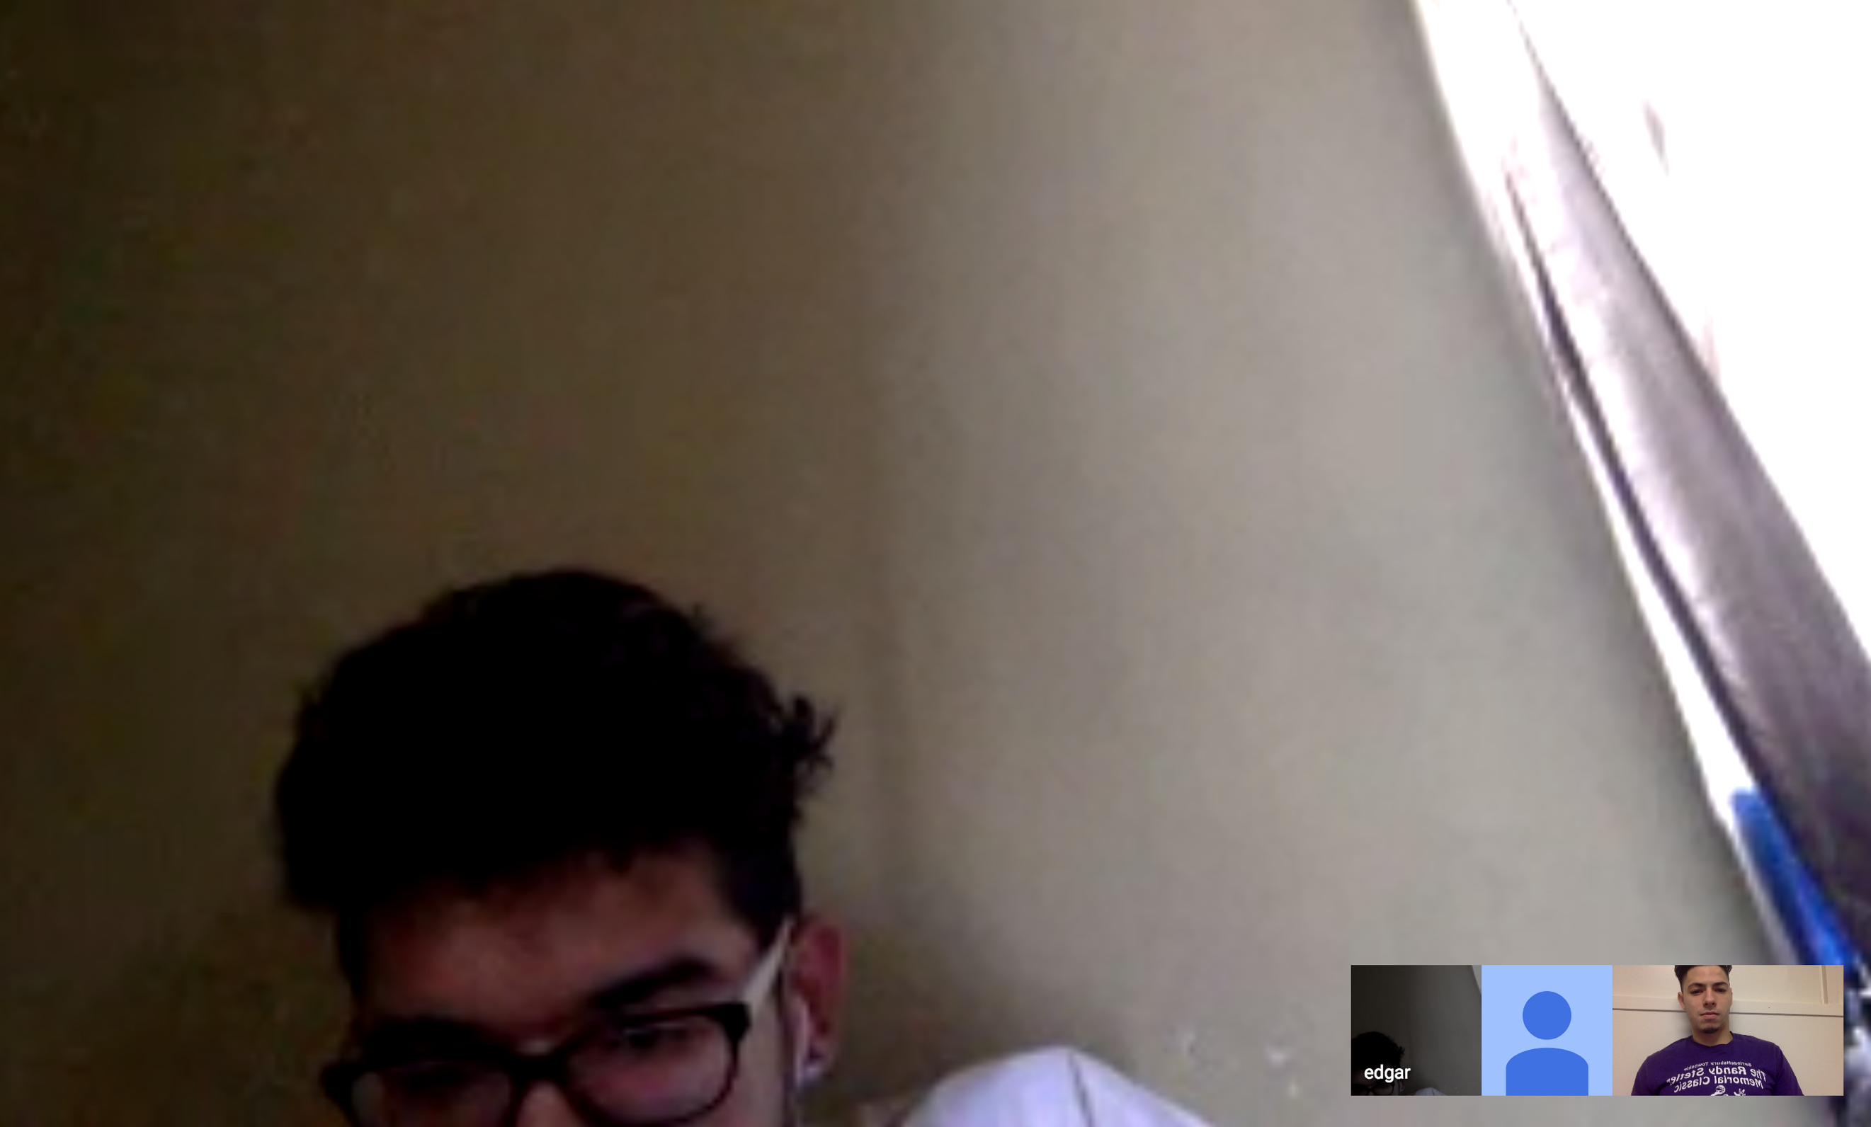

Right after the stand-up meeting Edgar and I decided to troubleshoot/pair program our github issue and we ended up resolving it from 12:50 PM to 1:15 PM. While Jessie was working on an html page Edgar and I tried to figure it out why github kept on deleting my code and we fixed it within 15-20 minutes.

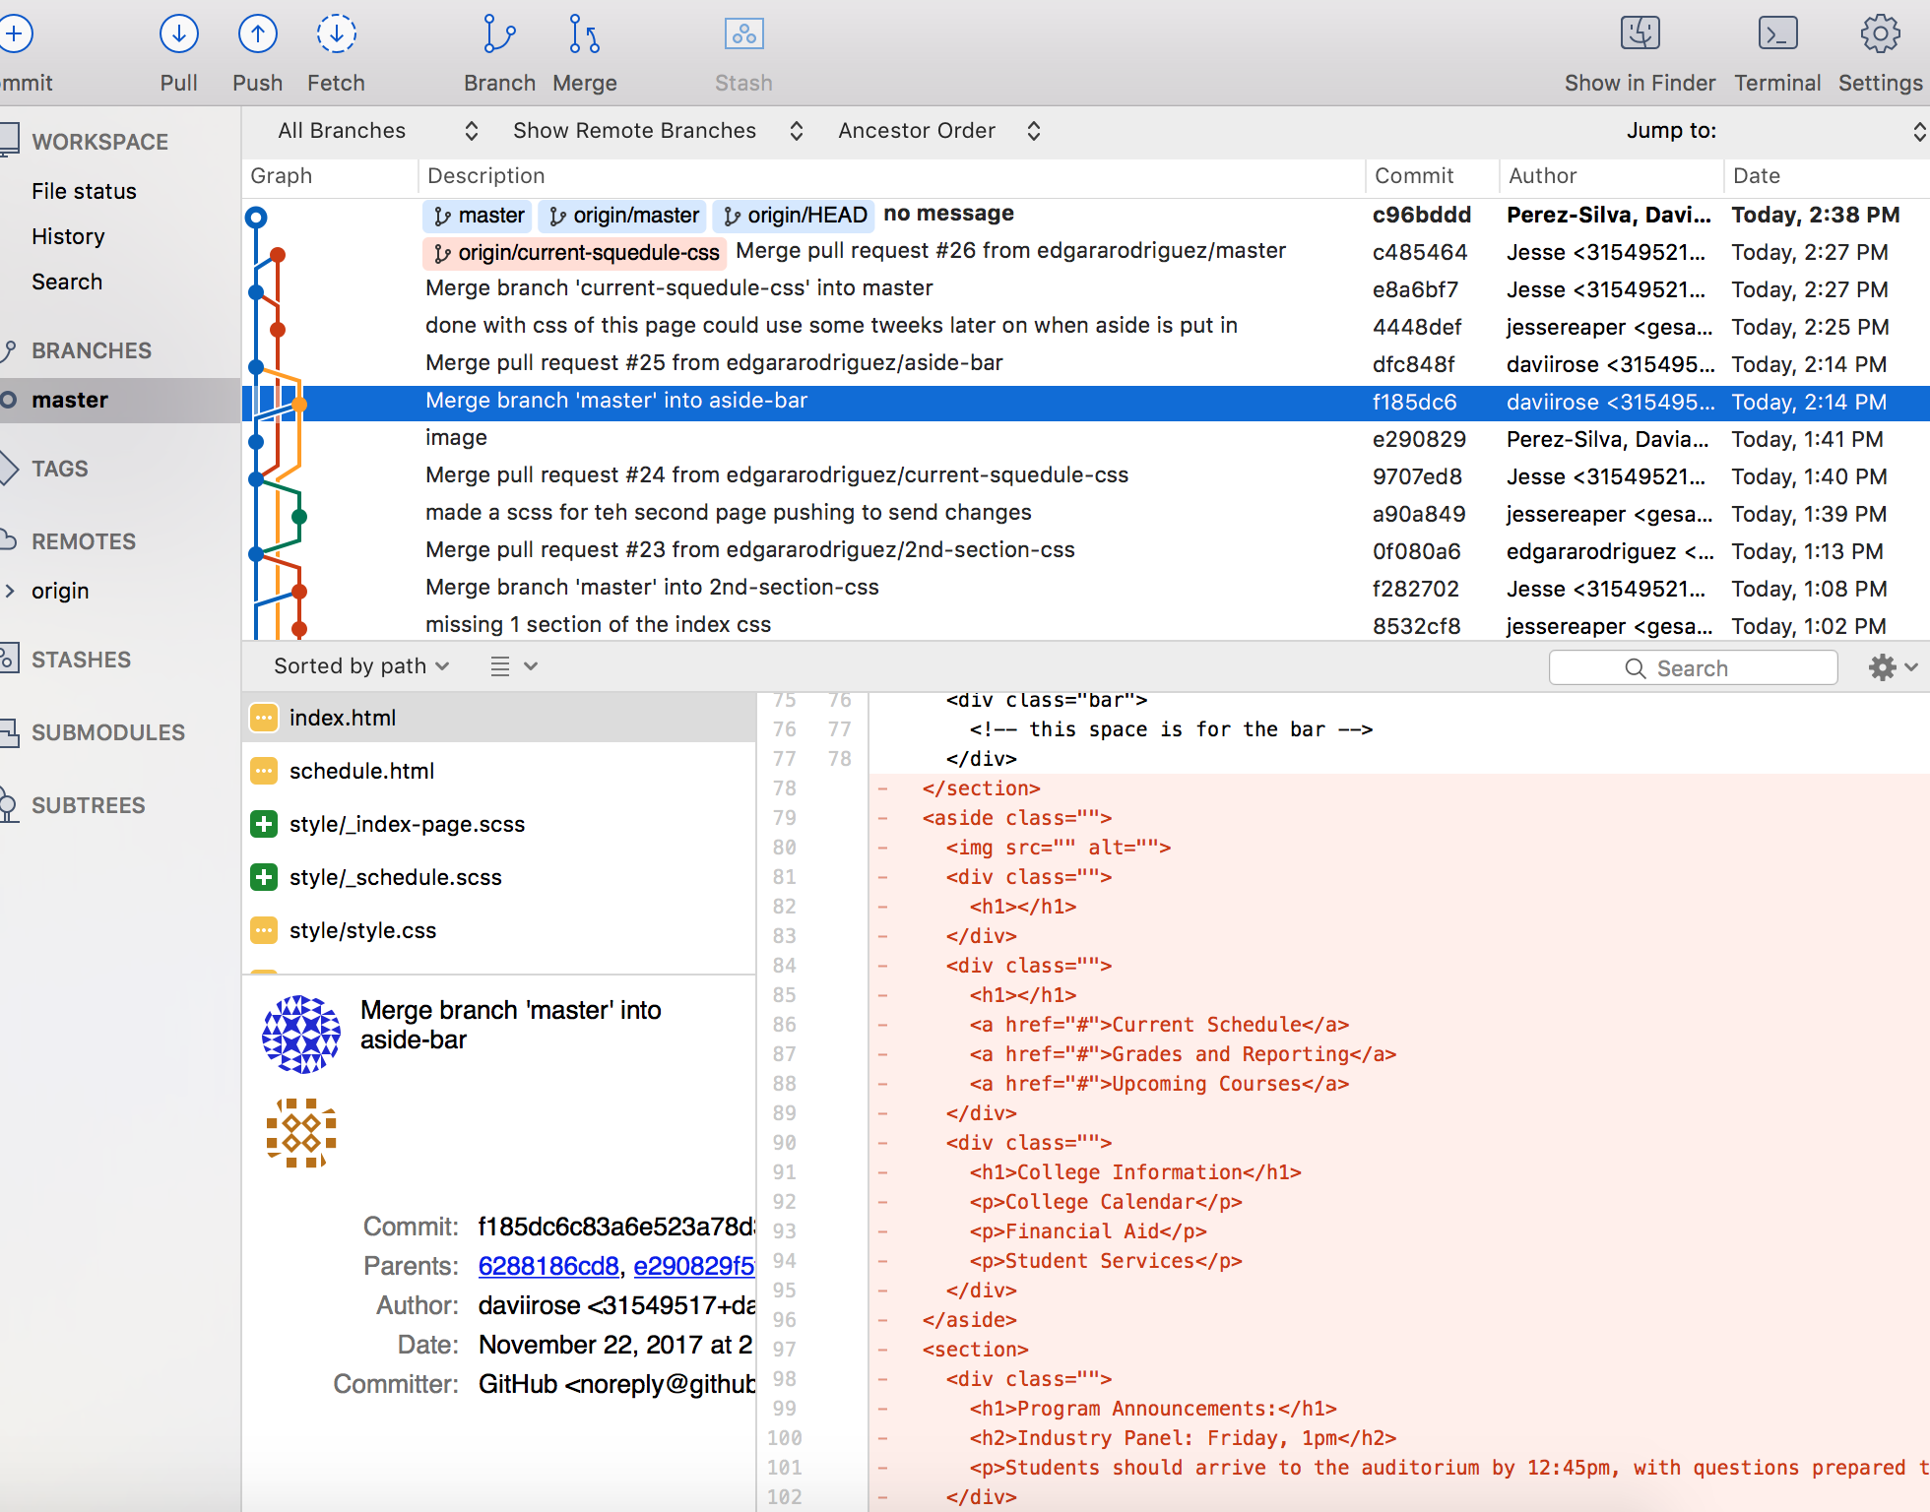

I thought working remotely was really interesting and fun, although it felt like I was overwhelmed in the beginning due to the fact that slack was set up differently I enjoyed working this way. There aren’t really any distractions and working by myself felt better than being around a lot of people in a room. Our group communicated very well and we got a big chunk of our project done.

I think I would be successful working this way because I like to stay to myself and do my work without being surrounded by too many people. I can focus better and procrastinate less believe it or not. I think working like this would only be enjoyable to people that are very independent and that would love to work from home.

The only thing that bothered me was the WIFI, I couldn’t communicate with my group through hangout that well, we still talked about everything even though it lagged half the time. Most of our communication came from the group chat which was pretty consistent especially when somebody needed a PR or a question to be answered.

Time stand

12:30-12:36= Got our group together on google hangout

12:36-12:45=Standup meeting

12:45-1:15= Resolved our conflict

1:16-1:20=Separated our work

1:20-2:30= Coded our pages that we assigned